A conference for
high school students
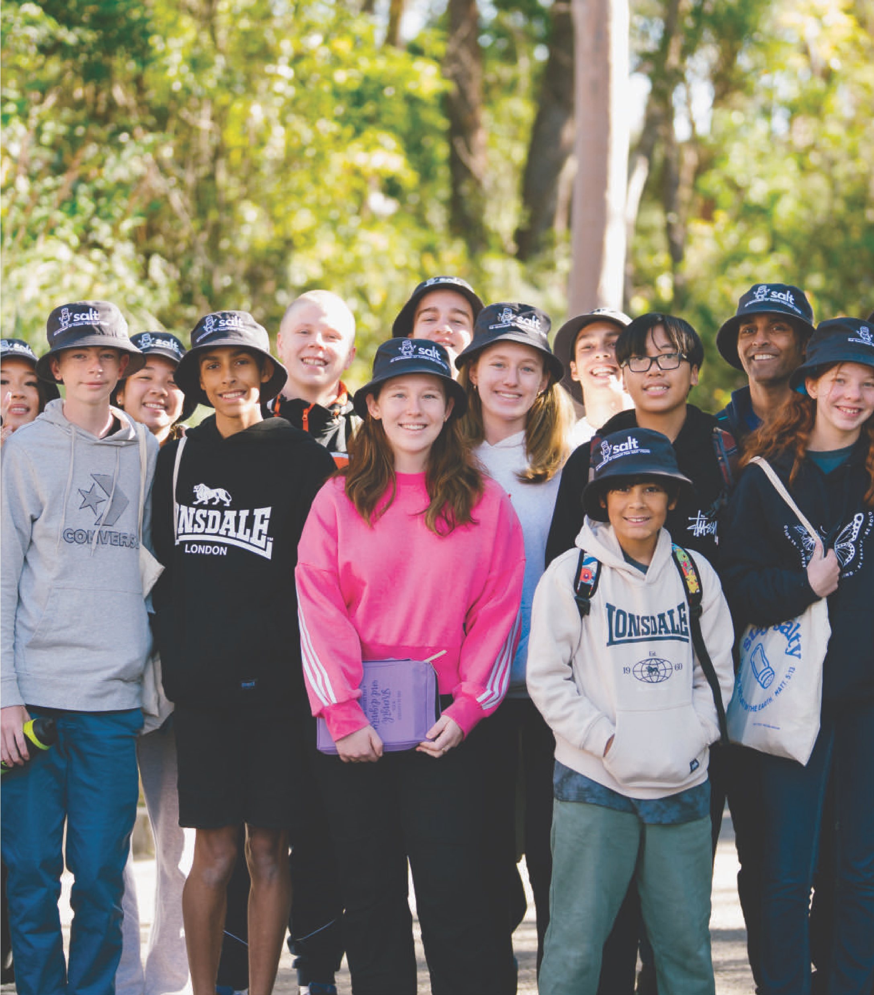
KYCK 1 9-11 April
KYCK 2 16-18 April
KYCK 3 23-25 April
KYCK 4 24-26 September
StayKCC
119 Cliff Drive,
Katoomba NSW 2780

Guidelines
Thank you for choosing to use a Social Story written for the KYCK conference. This Social Story is written by KCC for students who are neurodivergent and/or have language, social or cognitive difficulties.

For your Social Story to be successful, we recommend you follow these guidelines.
- Read Social Story often and preferably 2 weeks in advance of visit.
- Social Story to be read and shared in an environment free of distractions.
- Be calm, comfortable and honest when reading a Social Story.
- Help the participant comprehend key points and consistently monitor for level of understanding.
- Once the visit has taken place, revisit the Social Story to celebrate success.
Map
Accessible Parking
(
Permit Required
)
Accessible Toilet
Accessibility Path
Parking
Auditorium
Info Tent
First Aid Tent
Entry
Chill Zone
Toilets
For help or assistance at the event,
text or call
0403 455 842
A
E
C
+
A
E
E
C
+

I am going to the KYCK [number] event.
It is on from Friday night to Sunday lunch time.
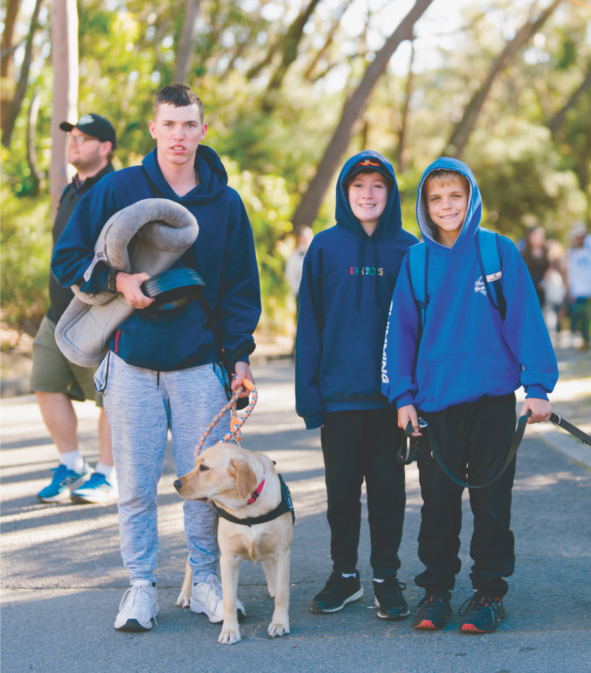
This event is for me to learn more about Jesus and the Bible.
It is a conference where young people like me listen to speakers, sing songs, join in fun activities and make friends.
I might feel excited, nervous or a little unsure, and that’s okay.

I will need to bring:
- Comfortable clothes
- Water bottle
- Any snacks I might need
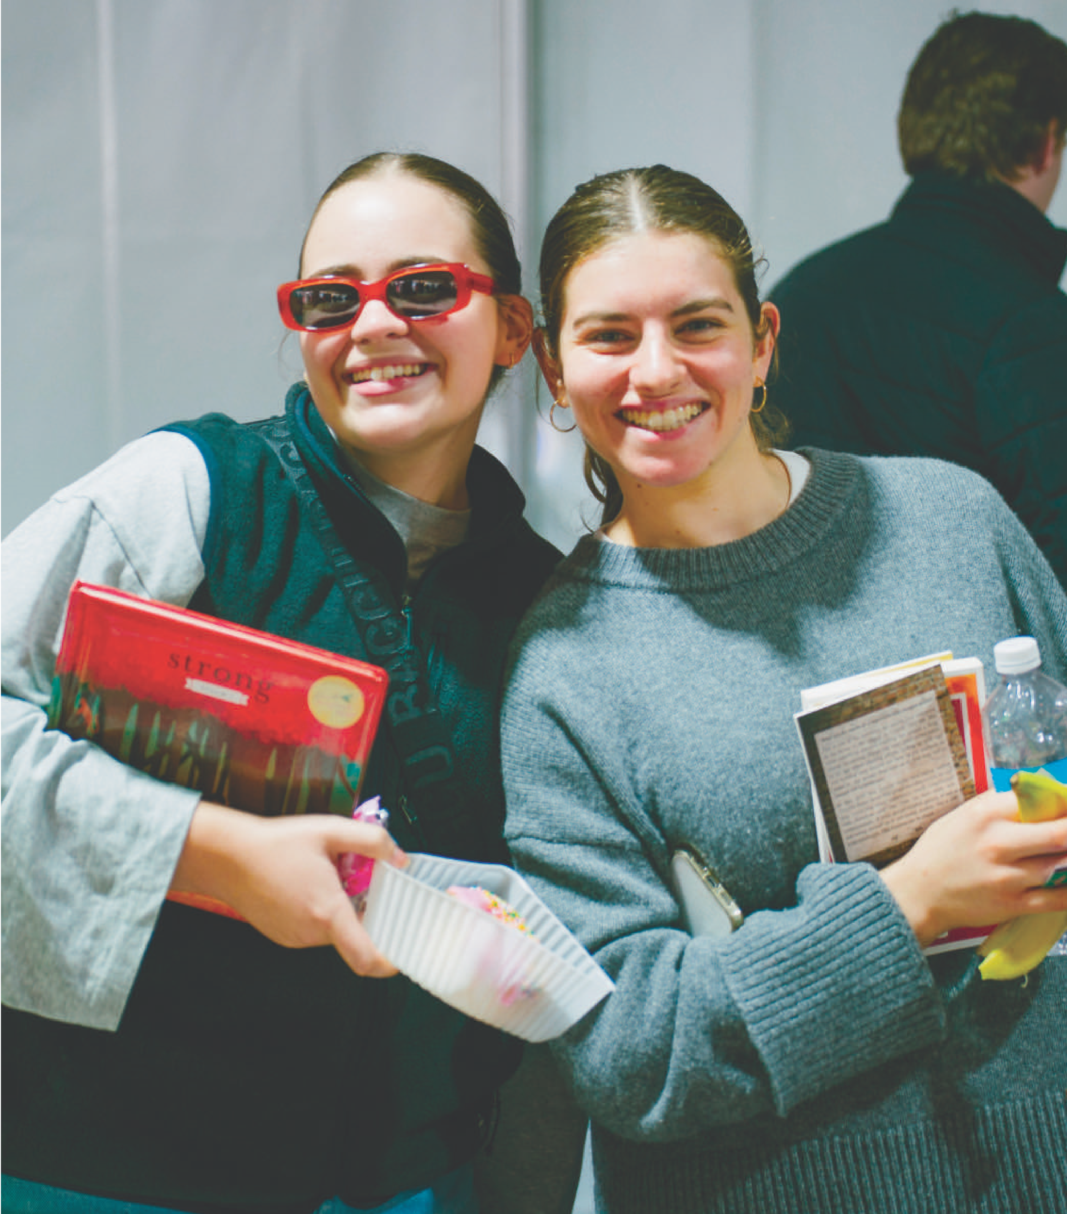
- My phone or small device, if I want to take photos or write about what I learn
I will be going with [name or group name] and there will be other youth and leaders at the conference too.
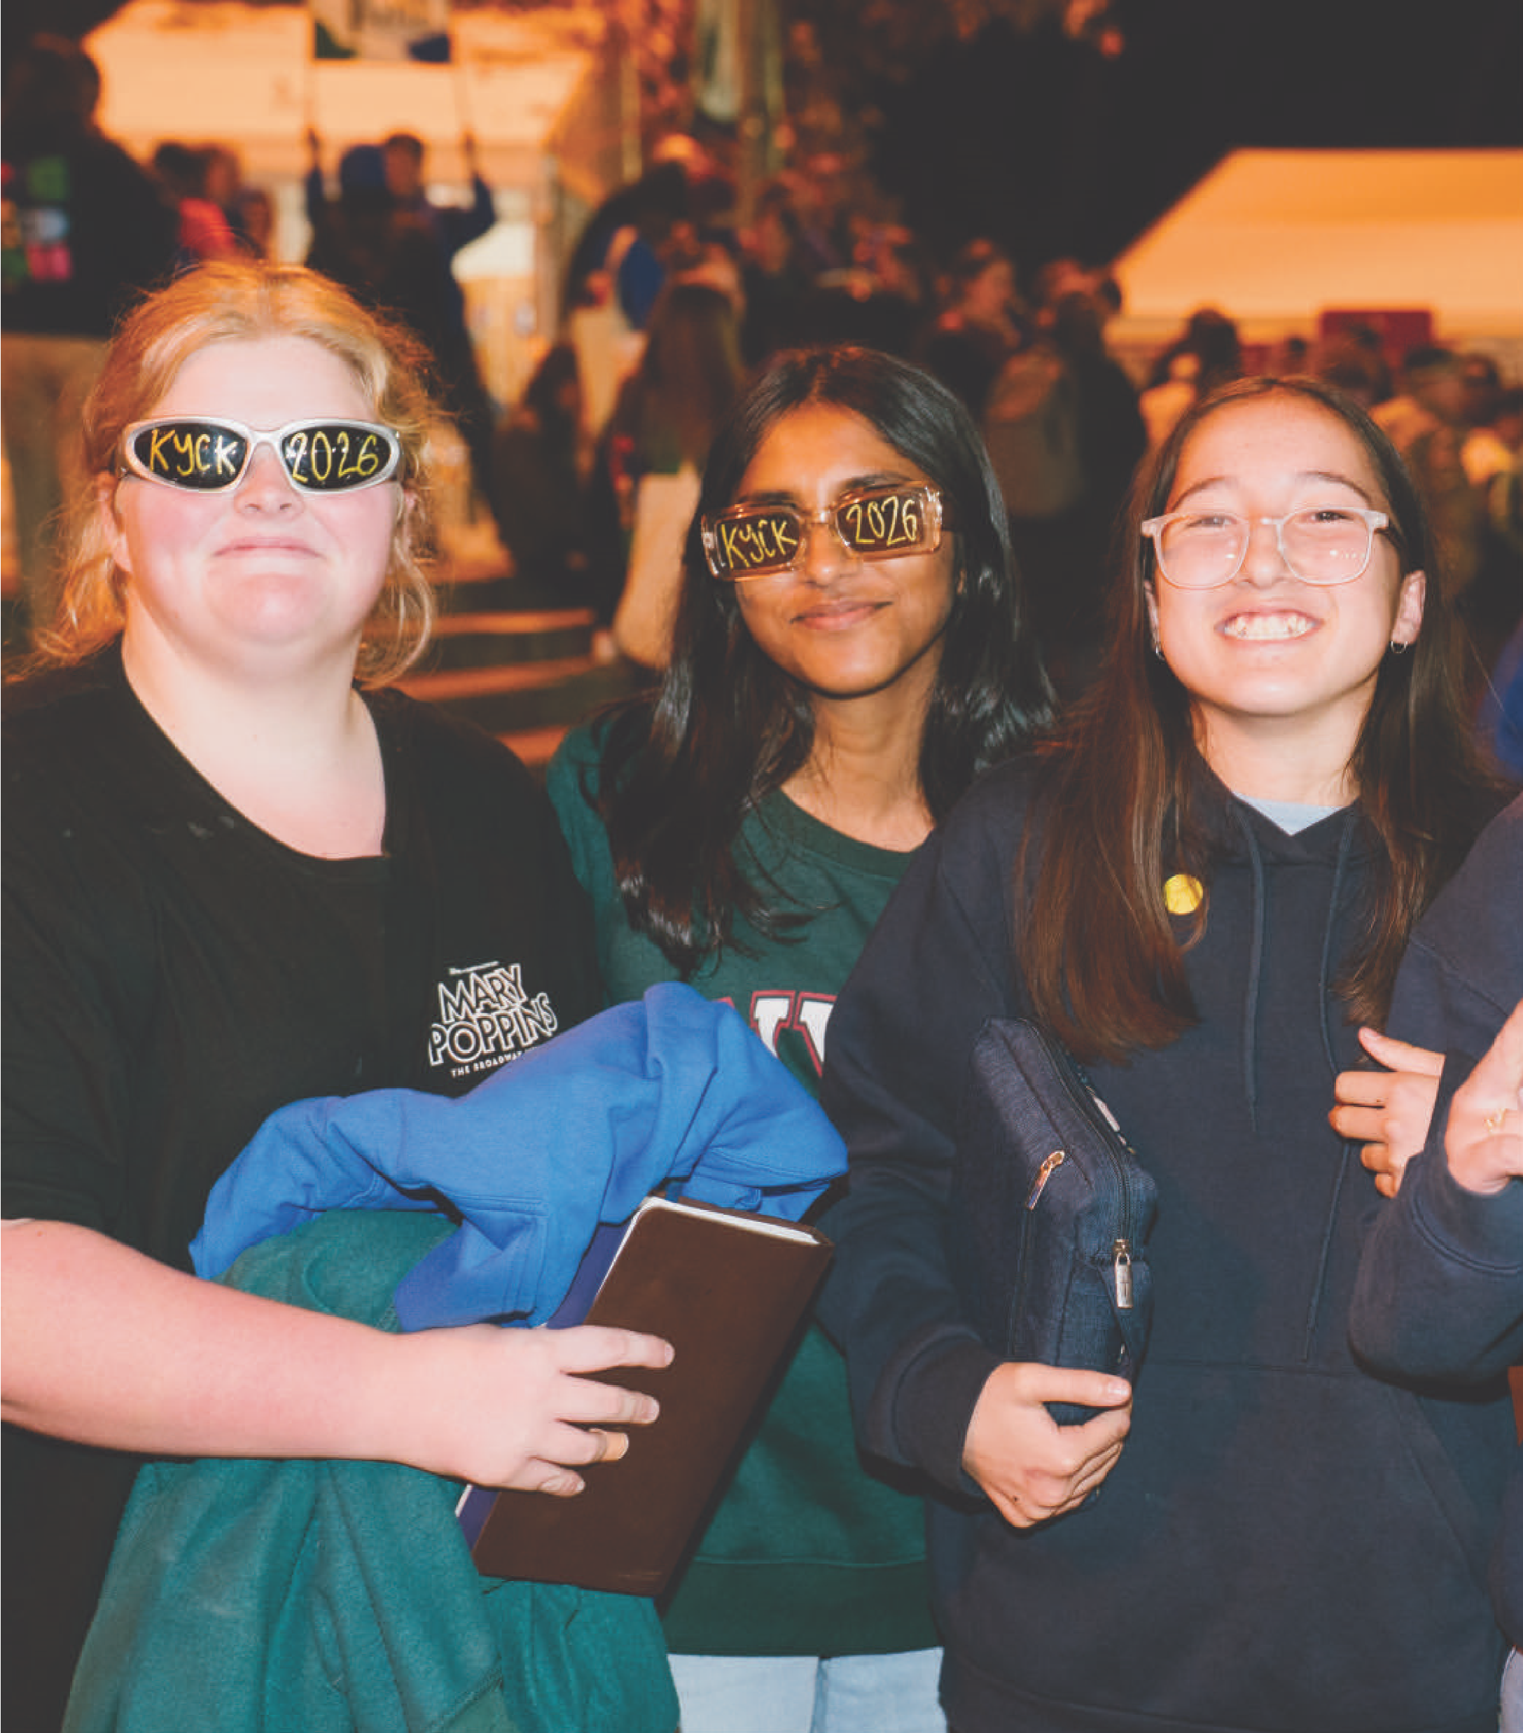
When I arrive, I will see lots of noisy and excited people waiting outside the auditorium.
Before I enter, I will need to show my wristband to the ushers wearing red vests. This is for safety reasons.
I will then go into the auditorium. It might feel crowded and that’s okay. I can ask for a break or move to a less crowded area.
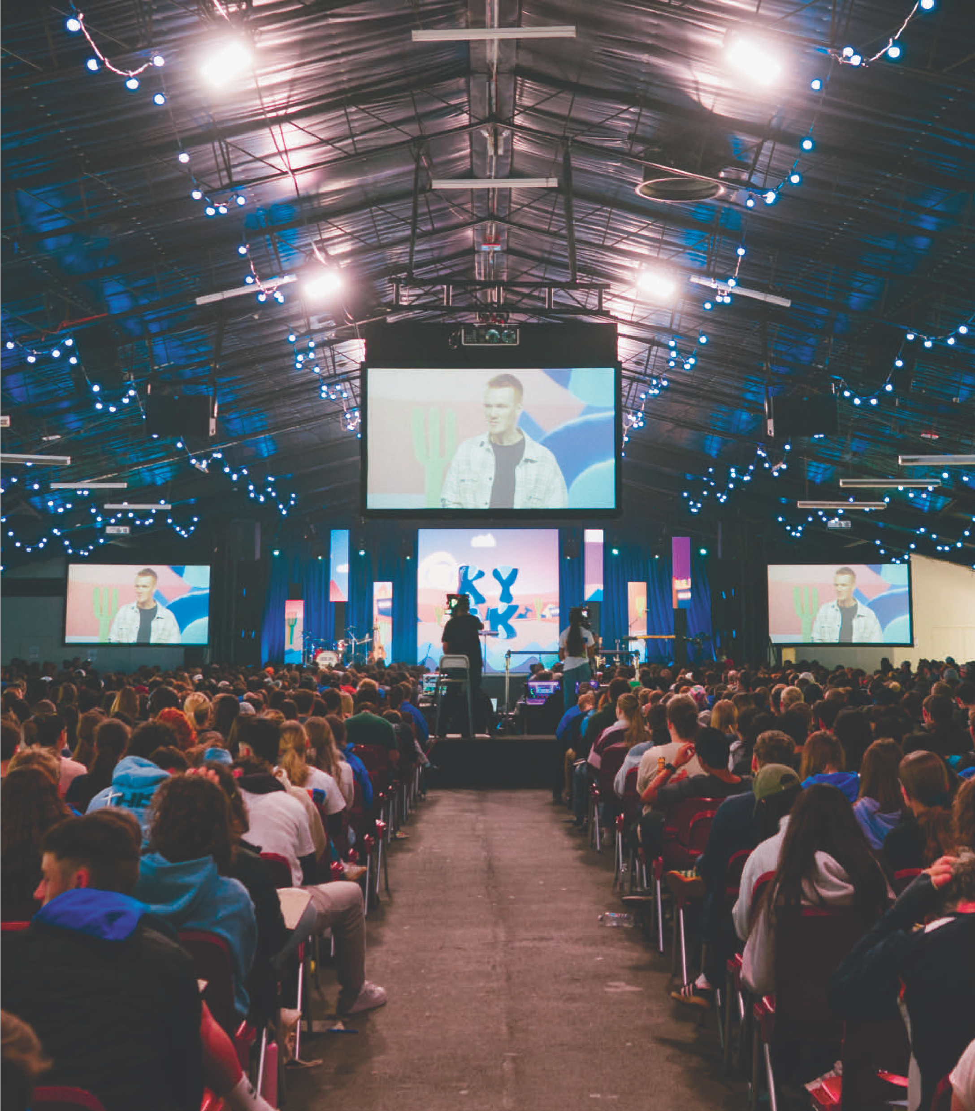
I can choose a seat from an area that the ushers tell me to go to. I can ask a leader or support person for help if I need to.
I might see people on stage organising fun games before the conference starts.

It can get very noisy at KYCK in the auditorium during sessions.
I might hear:
- clapping and cheering
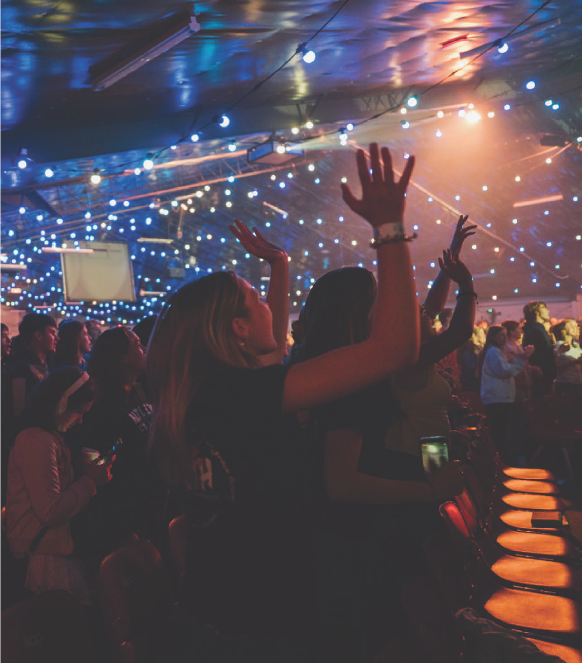
- music from a band or background music
- singing
- people talking on stage
I might also see lights flashing on stage, videos being played and flashes from the professional photographer’s camera.

I might wear my ear defenders to help with the noise.
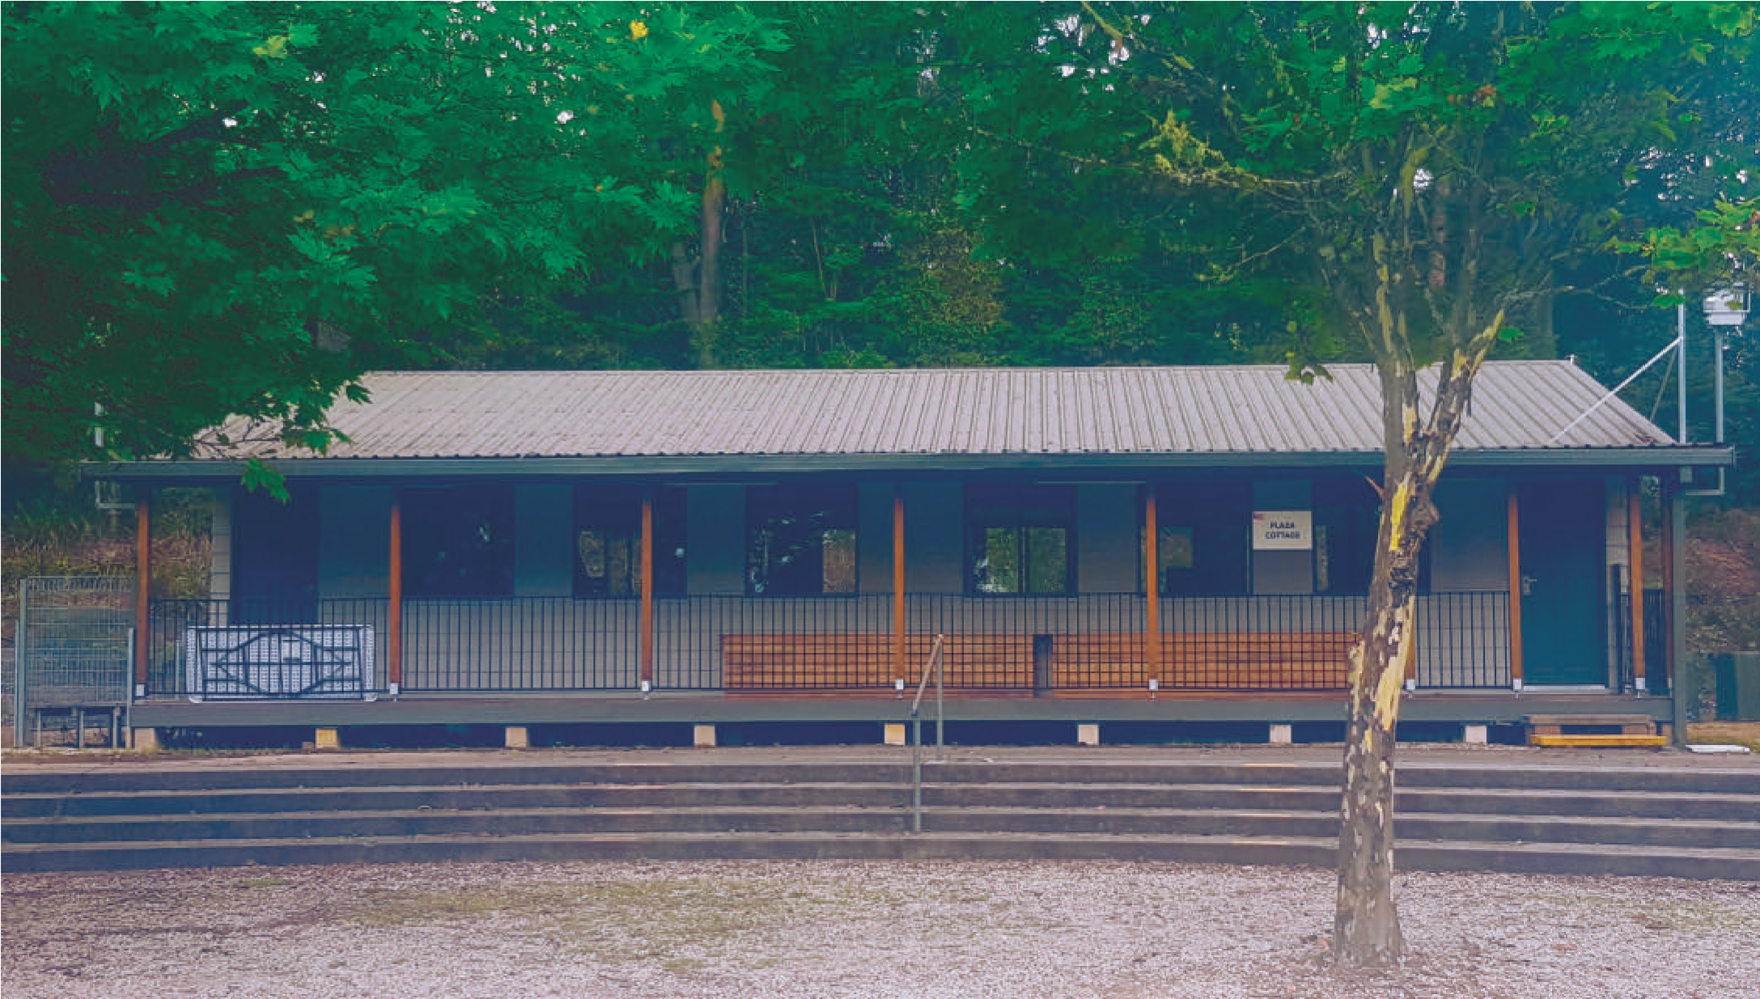
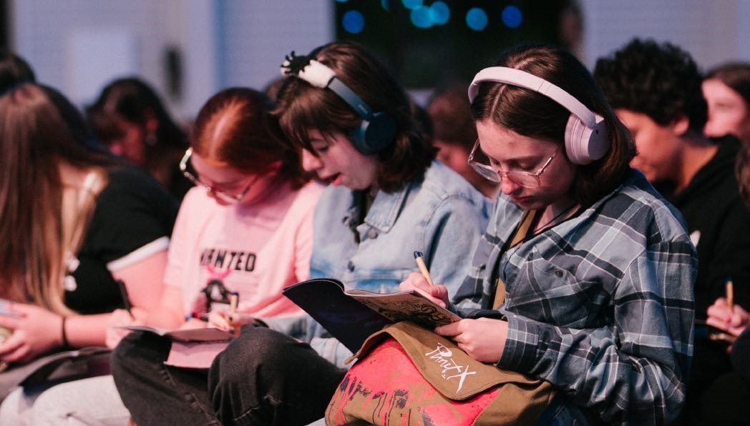
I can also bring a hat, sunglasses and stimming fidget toy devices into the auditorium.
I can go to a quiet building called the chill zone to relax.
My support person will need to go with me and the event staff can tell me where to go.
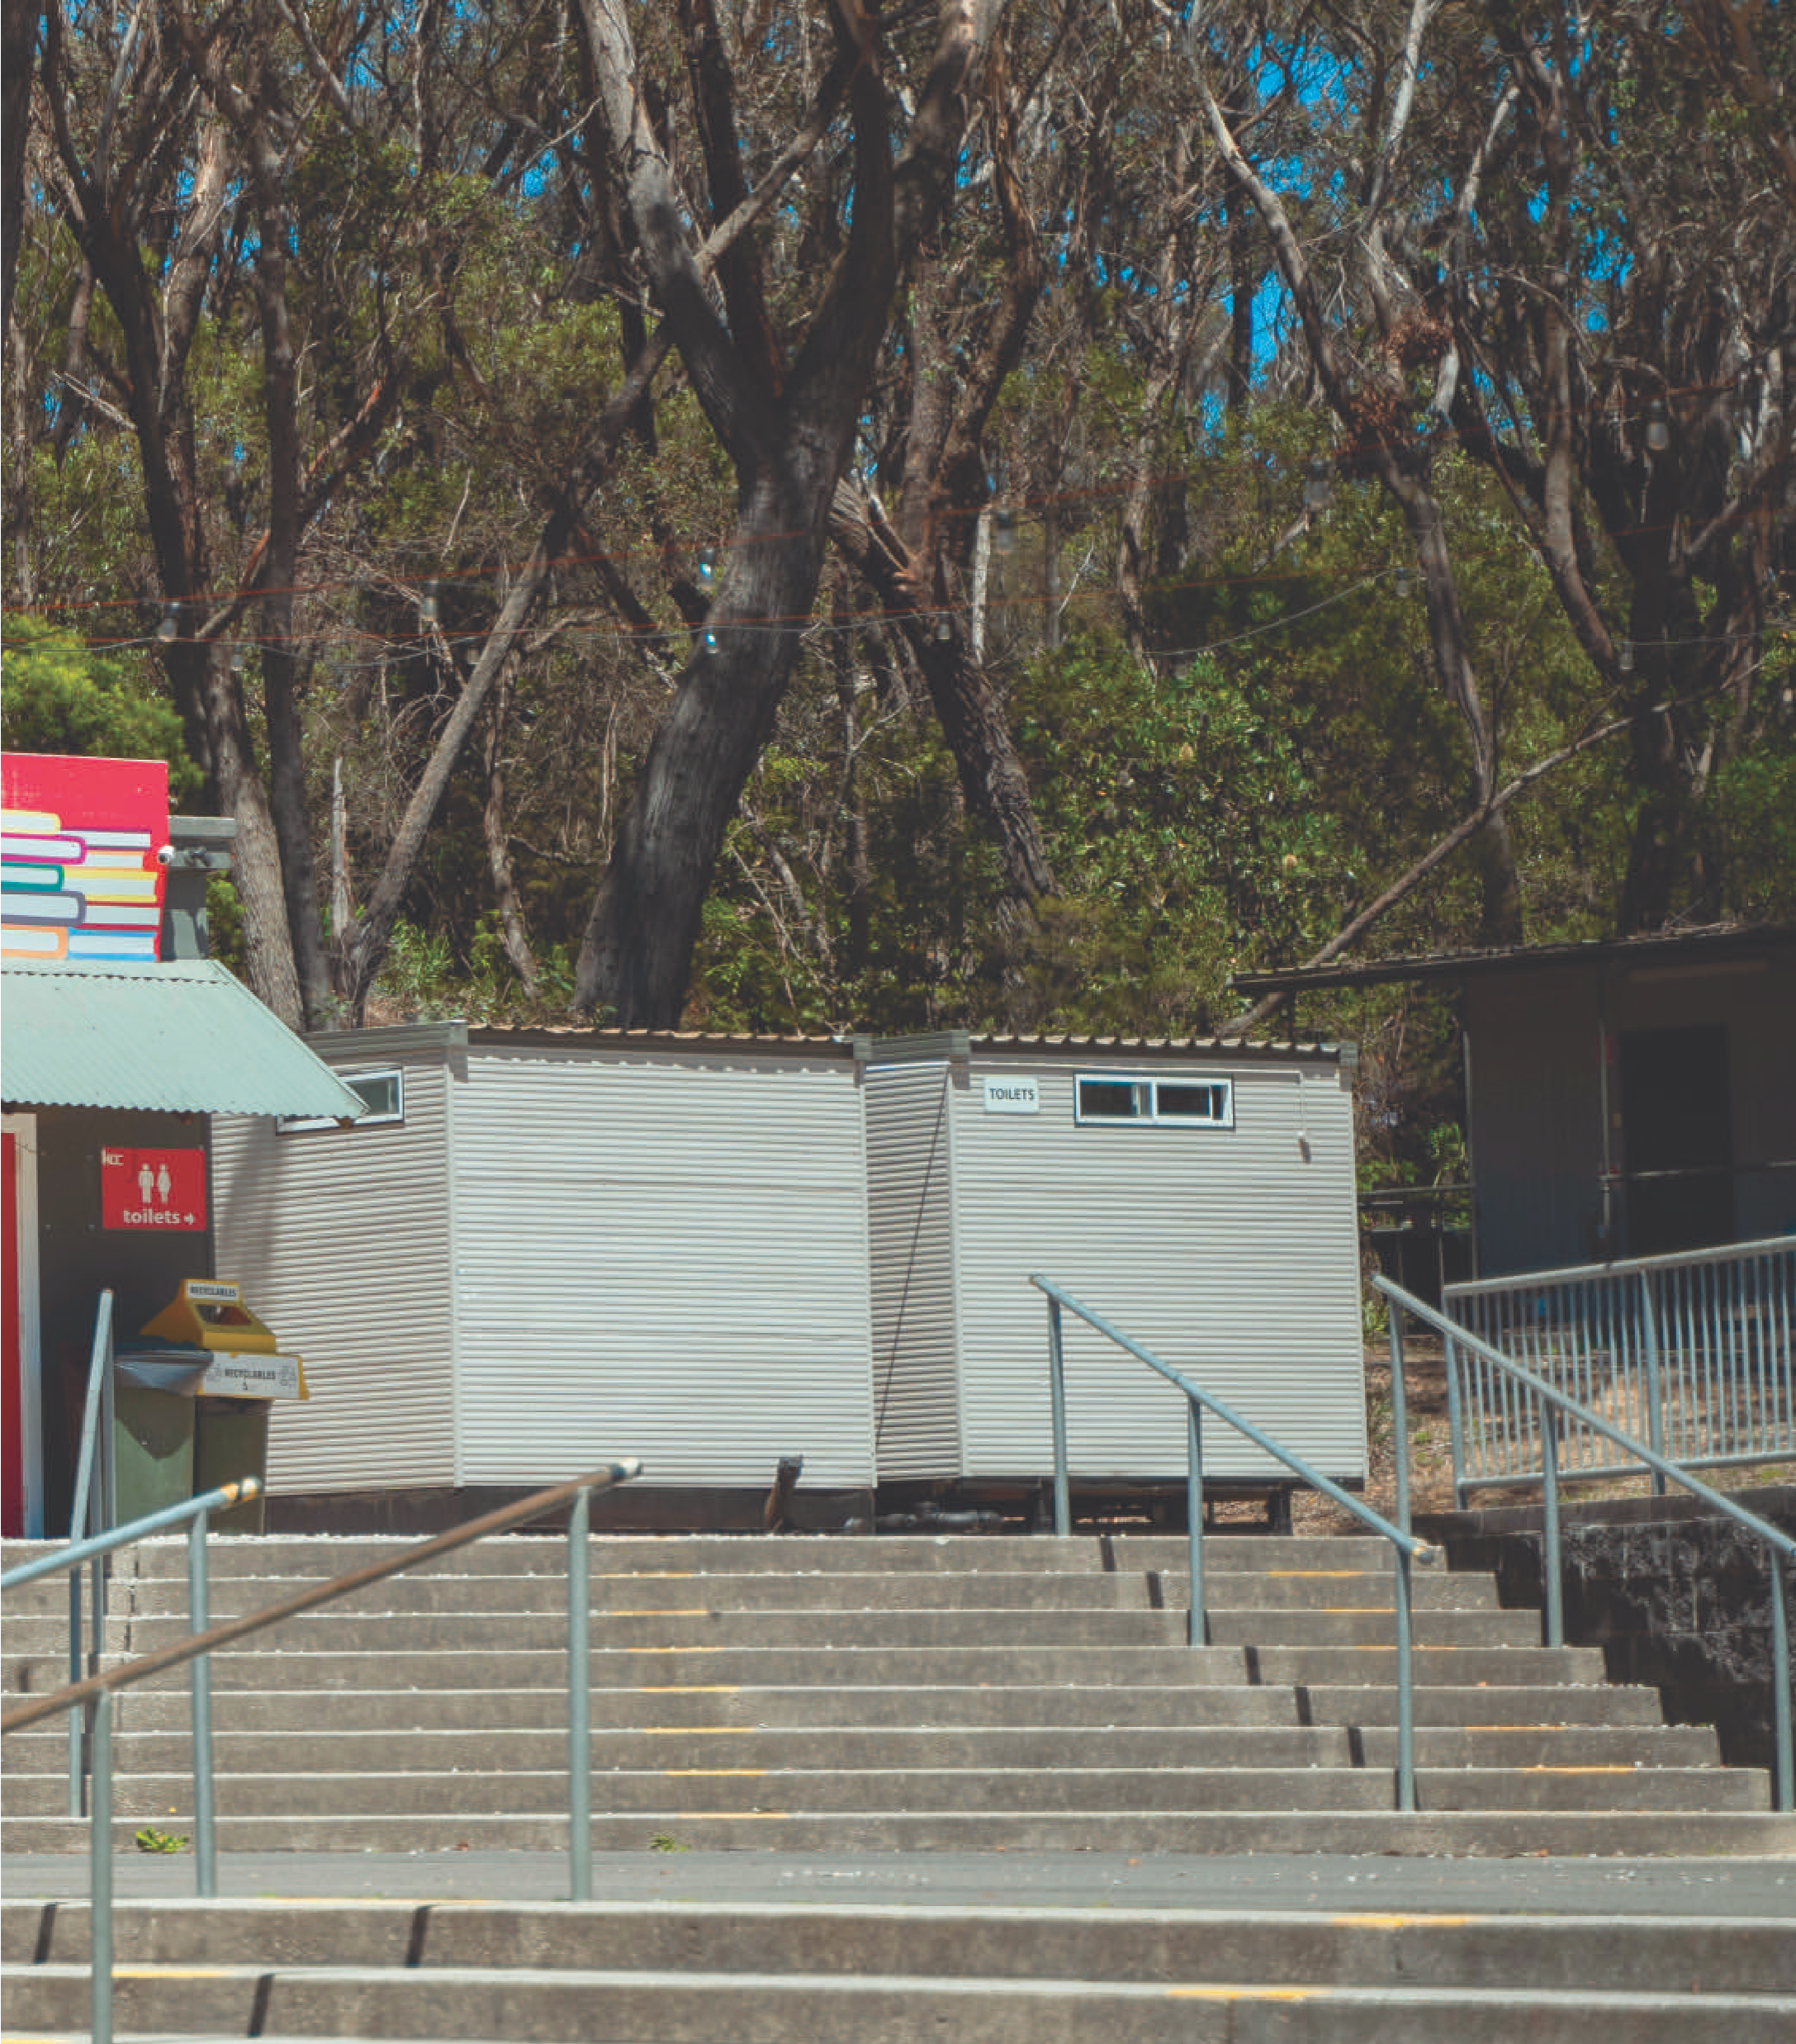
There are toilets outside the auditorium.
My support person or event staff can show me where the toilets are.
I can get free snacks and drinks for morning tea break.
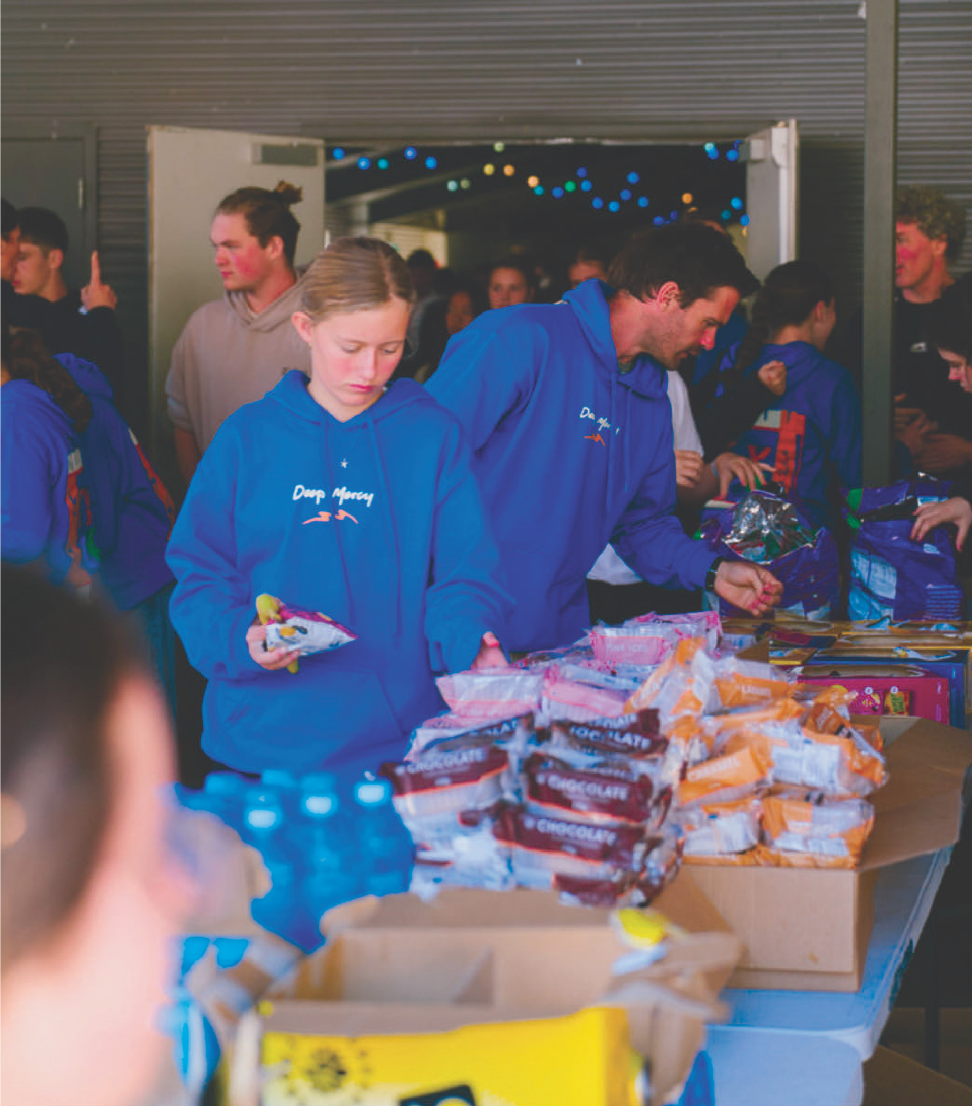
I might wait in a line to pick up my food and drink or my support person can do this for me.
I may buy a hot drink or cold slushie from the coffee cart.
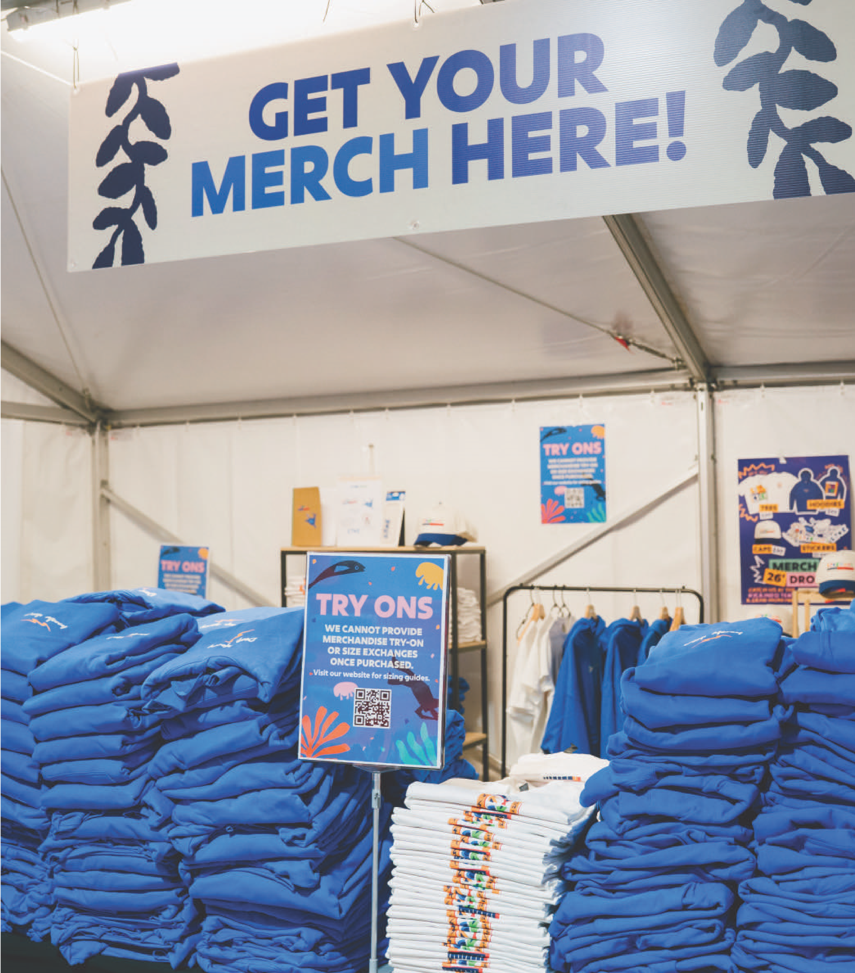
I might buy merchandise at the info tent using cash or my credit card.
If I need help, I can ask the KCC staff or a volunteer.
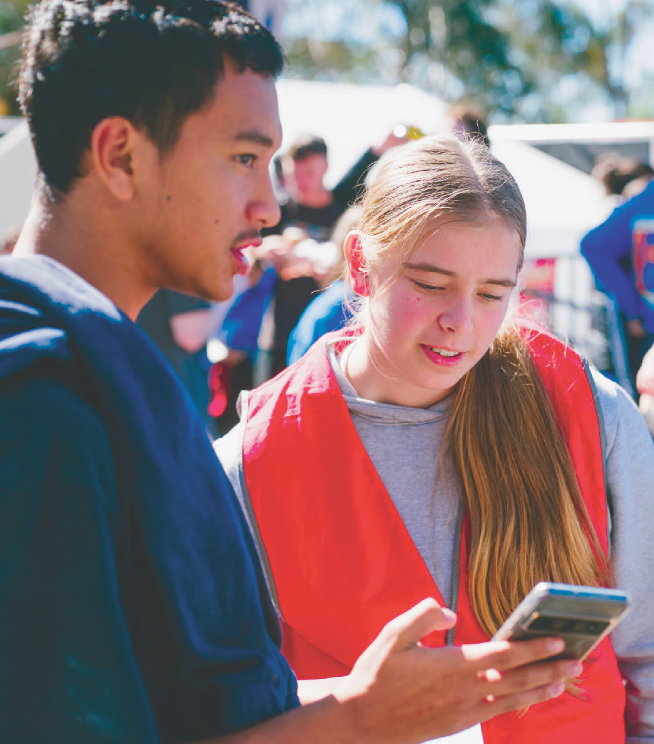
They wear red vests or red name lanyards. I may see them in the auditorium or the info tent.
I might like to email info@kcc.org.au or text 0403 455 842.

If I need medical help, I can visit staff in the First Aid Tent.
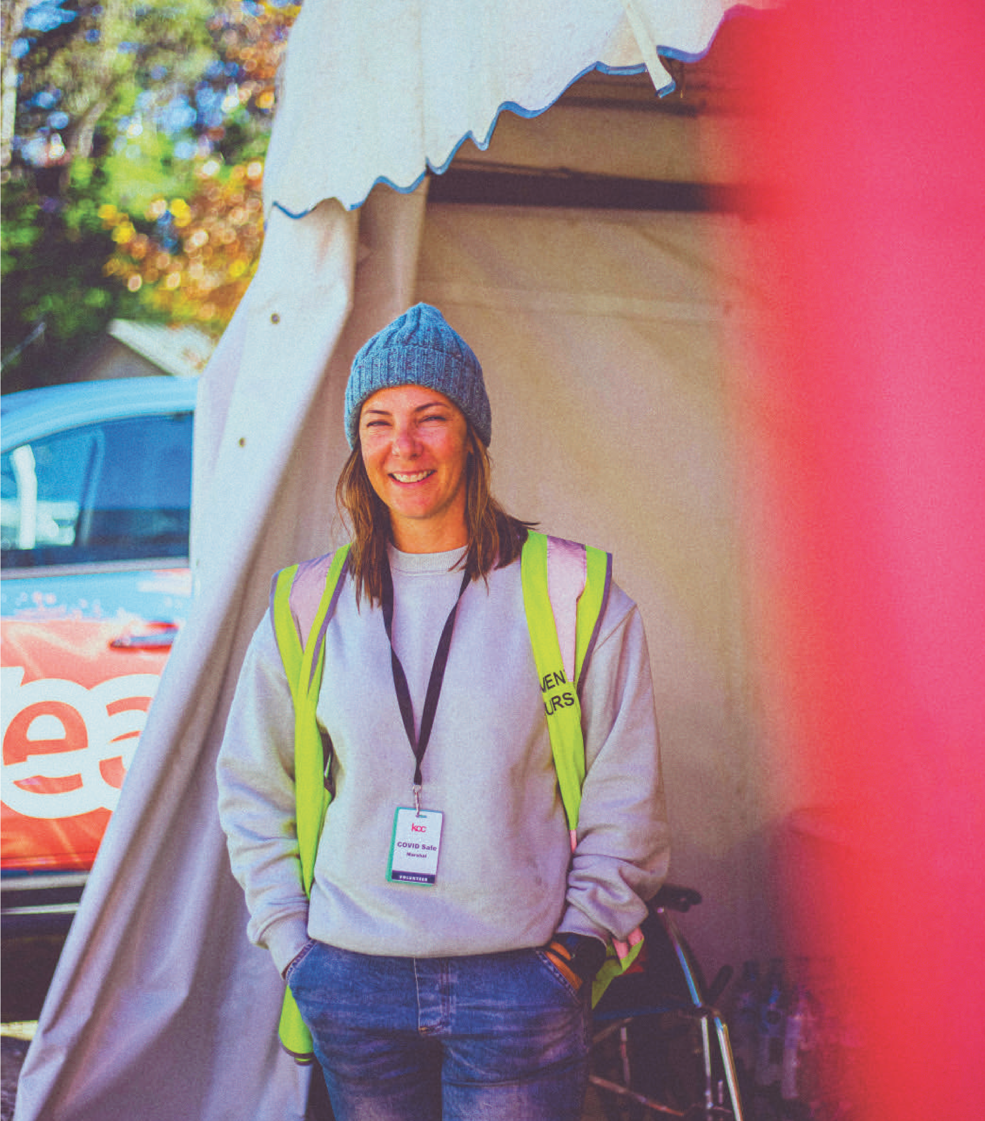
I may ask event staff to bring a first aider to me if I need to.
They wear a yellow vest and name lanyard.
KYCK will be an exciting and sometimes busy event.
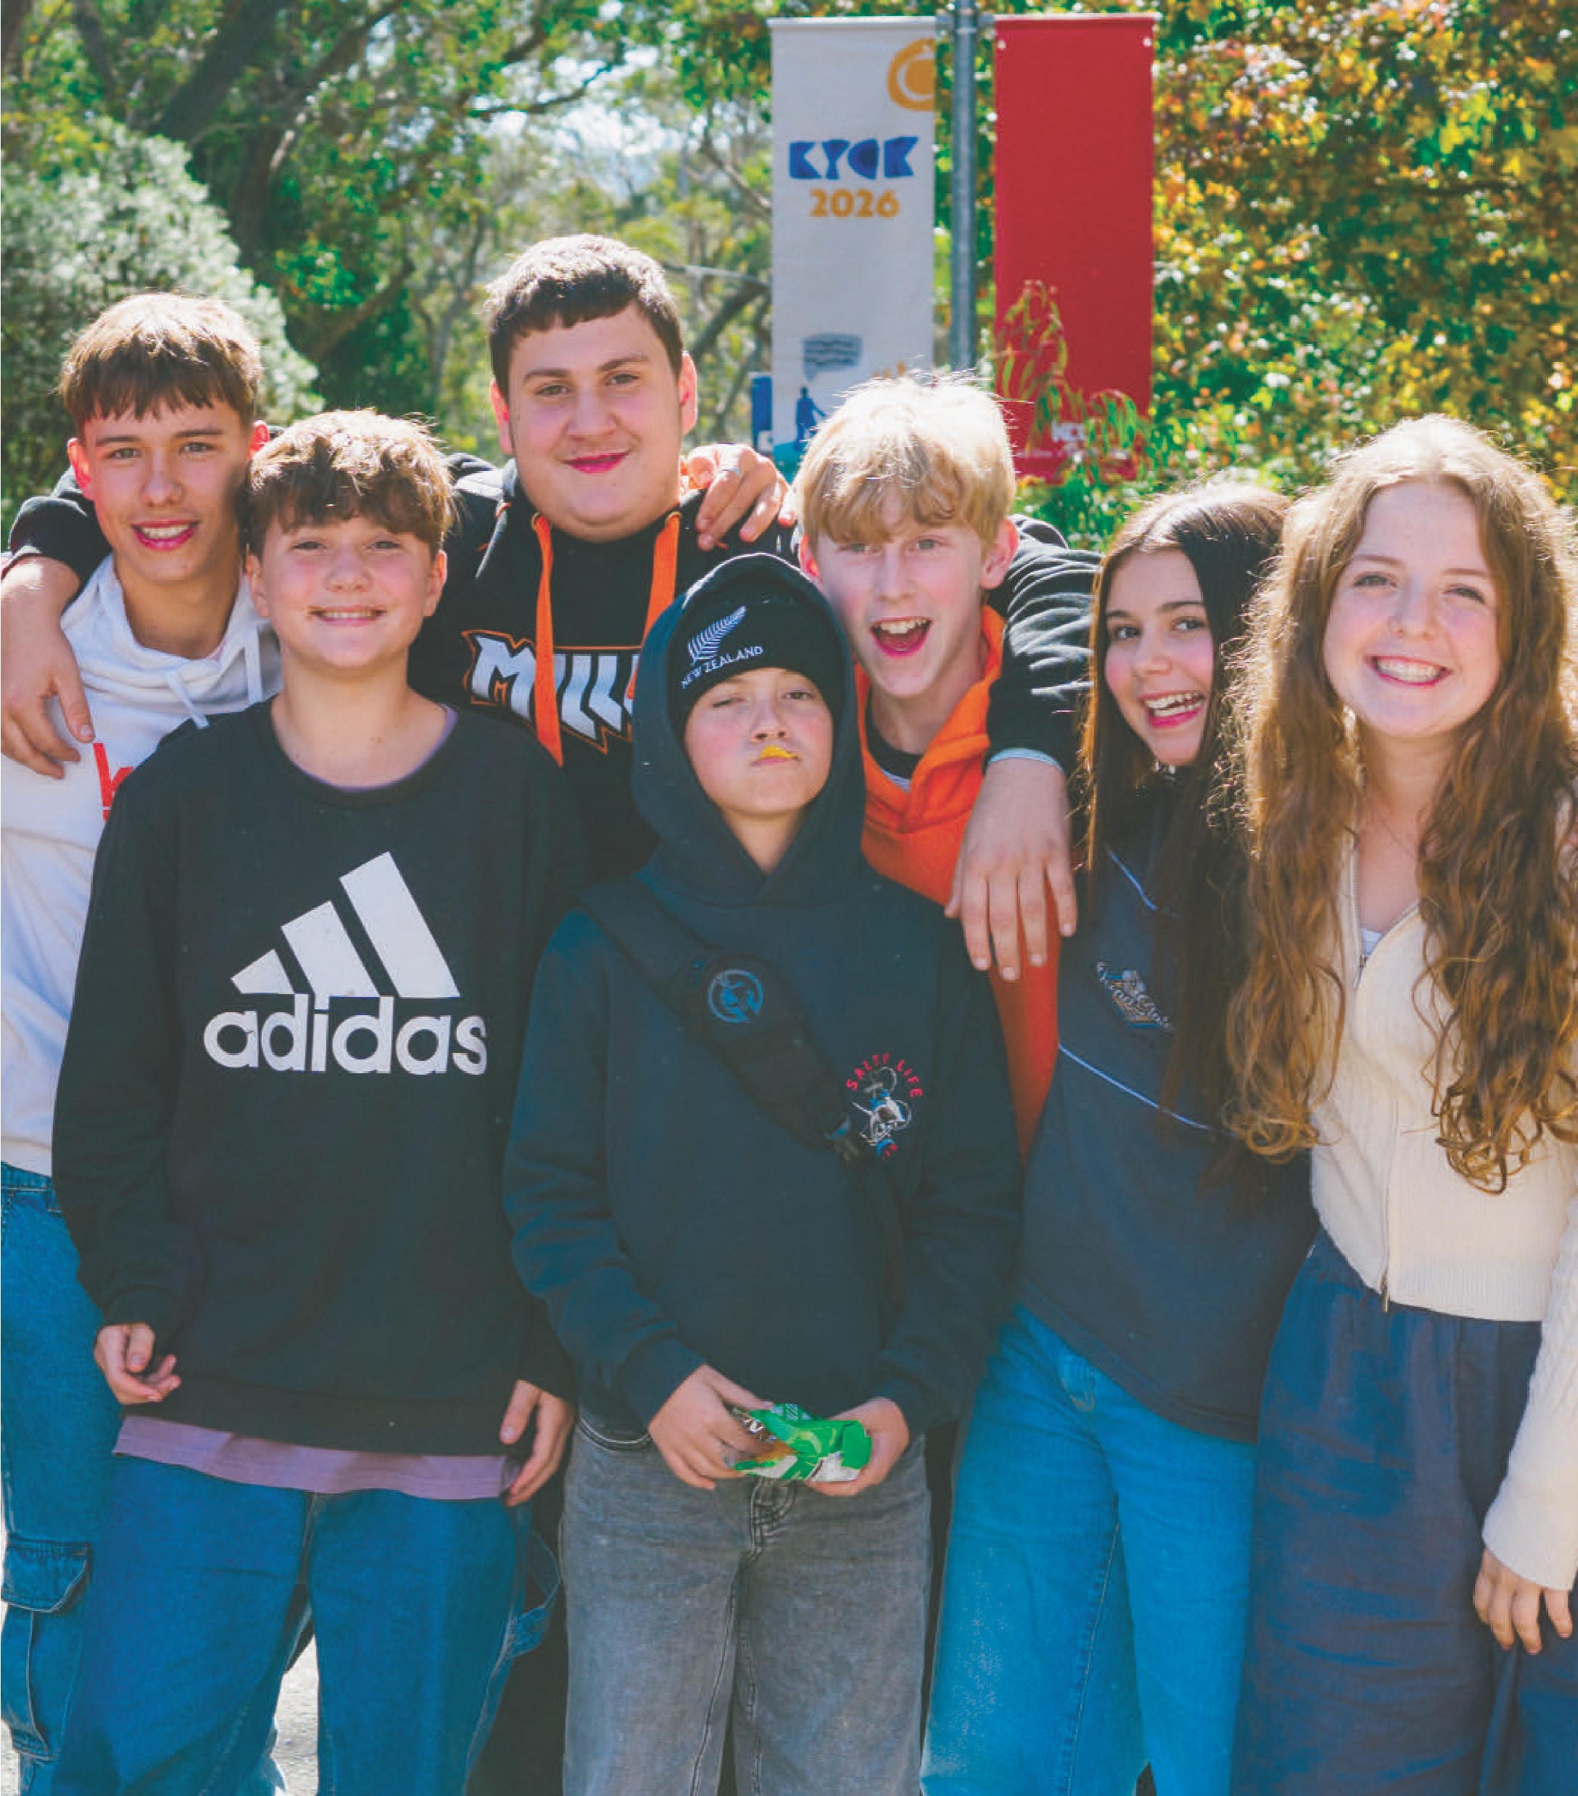
I can take it at my own pace, and I don’t need to worry if I need help.
I am going to have a chance to learn, be with my youth group and have fun.

Contact

Katoomba Christian Convention (KCC)
Phone: 1300 737 140
Email: info@kcc.org.au
Website: kyck.org.au

